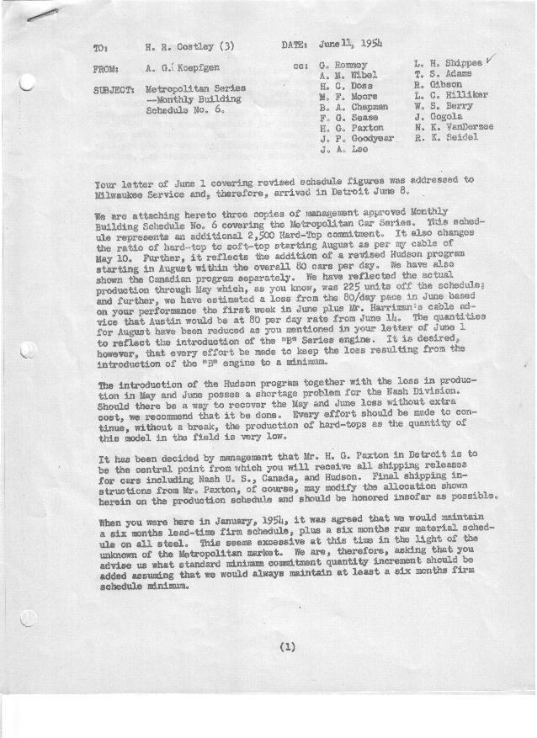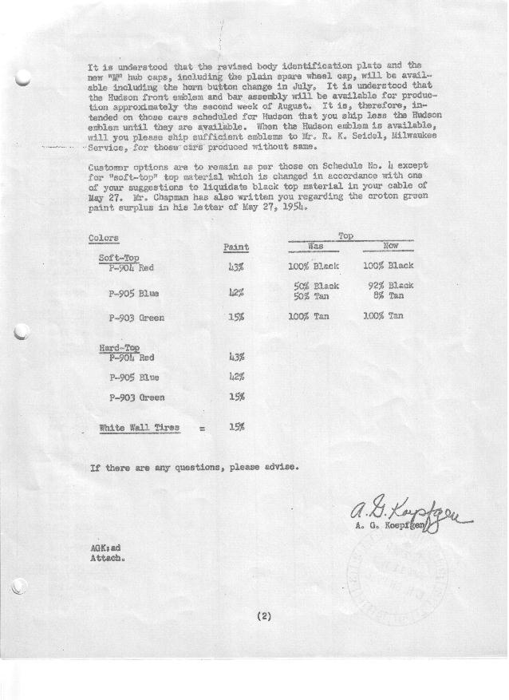

FORM PLAN 68 REV. 9-40-N.K.P PRINTED IN U.S.A

SCHEDULE NO. ______6_________ DATE June 9, 1954 MONTHLY BUILDING SCHEDULE APPROVED_____F. G. Sease (signed) ________DATE__ 6-11-54 ___ REVISION NO. ________________ DATE ________________ PRODUCT APPROVED_____B. A. Chapman (signed) ___________DATE_ _6-11-54____ ___
Metropolitan Series Cars – Austin Motors Co., Ltd., - England
DESCRIPTION | BUILT  ◻ACT EST  THRU  5-31-54 | FIRM BUILDING SCHEDULE  (FABRICATED MATERIAL RELEASE) |  |  |  |  |  |  |  |  |  |  |  |  |  |  |  |  |  | GRAND  TOTAL
DESCRIPTION | BUILT  ◻ACT EST  THRU  5-31-54 | MONTH June  DAYS 19 (3 days down) |  |  | MONTH July  DAYS 17 (5 days down) |  |  | MONTH August  DAYS 12 (10 days down) |  |  | MONTH September  DAYS 22 |  |  | MONTH October  DAYS 21 |  |  | MONTH November  DAYS 22 |  |  | GRAND  TOTAL
DESCRIPTION | BUILT  ◻ACT EST  THRU  5-31-54 | DAILY | MONTH | CUM’L  TOTAL | DAILY | MONTH | CUM’L  TOTAL | DAILY | MONTH | CUM’L  TOTAL | DAILY | MONTH | CUM’L  TOTAL | DAILY | MONTH | CUM’L  TOTAL | DAILY | MONTH | TOTAL | GRAND  TOTAL
NASH-CANADA
Hard-Top Convertible | 655 |  | 254 | 909 |  | 366 | 1275 |  | 100 | 1375 |  | 75 | 1450 |  | 75 | 1525 |  | 75 | 1600
Soft-Top Convertible | 251 |  | 49 | 300 |  | 0 | 300 |  | 0 | 300 |  | 0 | 300 |  | 0 | 300 |  | 0 | 300
Total | 906 |  | 303 | 1209 |  | 366 | 1575 |  | 100 | 1675 |  | 75 | 1750 |  | 75 | 1825 |  | 75 | 1900
NASH – U.S.
Hard-Top Convertible | 2887 |  | 866 | 3753 |  | 688 | 4441 |  | 430 | 4871 |  | 843 | 5714 |  | 803 | 6517 |  | 991 | 7508
Soft-Top Convertible | 2884 |  | 277 | 3161 |  | 306 | 3467 |  | 0 | 3467 |  | 0 | 3467 |  | 0 | 3467 |  | 132 | 3599
Total | 5771 |  | 1143 | 6914 |  | 994 | 7908 |  | 430 | 8338 |  | 843 | 9181 |  | 803 | 9984 |  | 1123 | 11107
NASH- TOTAL
Hard-Top Convertible | 3542 |  | 1120 | 4662 |  | 1054 | 5716 |  | 530 | 6246 |  | 918 | 7164 |  | 878 | 8042 |  | 1066 | 9108
Soft-Top Convertible | 3135 |  | 326 | 3461 |  | 306 | 3767 |  | 0 | 3767 |  | 0 | 3767 |  | 0 | 3767 |  | 132 | 3899
Total | 6677 |  | 1446 | 8123 |  | 1360 | 9483 |  | 530 | 10013 |  | 918 | 10931 |  | 878 | 11809 |  | 1198 | 13007
HUDSON - TOTAL
Hard-Top Convertible | 0 |  | 0 | 0 |  | 0 | 0 |  | 322 | 322 |  | 644 | 966 |  | 613 | 1579 |  | 496 | 2075
Soft-Top Convertible | 0 |  | 0 | 0 |  | 0 | 0 |  | 108 | 108 |  | 198 | 306 |  | 189 | 495 |  | 66 | 561
Total | 0 |  | 0 | 0 |  | 0 | 0 |  | 430 | 430 |  | 842 | 1272 |  | 802 | 2074 |  | 562 | 2636
CORPORATION - TOTAL
Hard-Top Convertible | 3542 | 59 | 1120 | 4662 | 62 | 1054 | 5716 | 71 | 852 | 6568 | 71 | 1562 | 8130 | 71 | 1491 | 9621 | 71 | 1562 | 11183
Soft-Top Convertible | 3135 | 17 | 326 | 3461 | 18 | 306 | 3767 | 9 | 108 | 3875 | 9 | 198 | 4073 | 9 | 189 | 4262 | 9 | 198 | 4460
Total | 6677 | 76 | 1446 | 8123 | 80 | 1360 | 9483 | 80 | 960 | 10443 | 80 | 1760 | 12203 | 80 | 1680 | 13883 | 80 | 1760 | 15643
Over/(Under) Sched. #5 | (225) |  | (74) | (299) |  | 0 | (299) |  | (320) | (619) |  | 0 | (619) |  | (80) | (699) |  | 1342 | 643
 |  | MONTH December  DAYS 18 Hard-Top  21 Soft-Top |  |  | Unscheduled |  |  | Grand Total
NASH-CANADA
Hard-Top Convertible |  |  | 75 | 1675 |  | 0 |  |  | 1675
Soft-Top Convertible |  |  | 0 | 300 |  | 0 |  |  | 300
Total |  |  | 75 | 1975 |  | 0 |  |  | 1975
NASH – U.S.
Hard-Top Convertible |  |  | 828 | 8336 |  | 0 |  |  | 8336
Soft-Top Convertible |  |  | 126 | 3725 |  | 351 |  |  | 4076
Total |  |  | 954 | 12061 |  | 351 |  |  | 12412
NASH- TOTAL
Hard-Top Convertible |  |  | 903 | 10011 |  | 0 |  |  | 10011
Soft-Top Convertible |  |  | 126 | 4025 |  | 351 |  |  | 4376
Total |  |  | 1029 | 14036 |  | 351 |  |  | 14387
HUDSON - TOTAL
Hard-Top Convertible |  |  | 414 | 2489 |  | 0 |  |  | 2489
Soft-Top Convertible |  |  | 63 | 624 |  | 0 |  |  | 624
Total |  |  | 477 | 3113 |  | 0 |  |  | 3113
CORPORATION - TOTAL
Hard-Top Convertible |  | 71 | 1317 | 12500 |  | 0 |  |  | 12500
Soft-Top Convertible |  | 9 | 189 | 4649 |  | 351 |  |  | 5000
Total |  | 80 | 1506 | 17149 |  | 351 |  |  | 17500
Over/(Under) Sched. #5 |  |  | 1506 | 2149 |  | 351 |  |  | 2500

